Frontend structure for clean code
1. Recommended Folder Structure
autodialer-frontend/
│
├── public/
│ └── logo.png
│
├── src/
│ │
│ ├── app/
│ │ ├── App.tsx
│ │ ├── routes.tsx
│ │ └── providers.tsx
│ │
│ ├── assets/
│ │ ├── icons/
│ │ └── images/
│ │
│ ├── components/
│ │ ├── common/
│ │ │ ├── Button.tsx
│ │ │ ├── Card.tsx
│ │ │ ├── Badge.tsx
│ │ │ ├── Input.tsx
│ │ │ ├── Table.tsx
│ │ │ └── Modal.tsx
│ │ │
│ │ ├── layout/
│ │ │ ├── DashboardLayout.tsx
│ │ │ ├── Sidebar.tsx
│ │ │ ├── Topbar.tsx
│ │ │ └── PageHeader.tsx
│ │ │
│ │ ├── dashboard/
│ │ │ ├── StatsCard.tsx
│ │ │ ├── CallStatusChart.tsx
│ │ │ ├── RecentCallsTable.tsx
│ │ │ └── LiveCallsPanel.tsx
│ │ │
│ │ ├── calls/
│ │ │ ├── CallDetailCard.tsx
│ │ │ ├── CallTranscript.tsx
│ │ │ ├── CallOutcomeBox.tsx
│ │ │ └── IVRPathTimeline.tsx
│ │ │
│ │ └── claims/
│ │ ├── ClaimInfoCard.tsx
│ │ ├── DenialReasonBox.tsx
│ │ └── PaymentInfoCard.tsx
│ │
│ ├── pages/
│ │ ├── DashboardPage.tsx
│ │ ├── CallsPage.tsx
│ │ ├── CallDetailsPage.tsx
│ │ ├── ClaimsPage.tsx
│ │ ├── PayersPage.tsx
│ │ ├── AnalyticsPage.tsx
│ │ └── SettingsPage.tsx
│ │
│ ├── services/
│ │ ├── apiClient.ts
│ │ ├── callsApi.ts
│ │ ├── claimsApi.ts
│ │ ├── payersApi.ts
│ │ └── analyticsApi.ts
│ │
│ ├── hooks/
│ │ ├── useCalls.ts
│ │ ├── useClaimDetails.ts
│ │ ├── useLiveCalls.ts
│ │ └── useDashboardStats.ts
│ │
│ ├── types/
│ │ ├── call.types.ts
│ │ ├── claim.types.ts
│ │ ├── payer.types.ts
│ │ └── dashboard.types.ts
│ │
│ ├── constants/
│ │ ├── routes.ts
│ │ ├── statusColors.ts
│ │ ├── menuItems.ts
│ │ └── appConfig.ts
│ │
│ ├── utils/
│ │ ├── formatDate.ts
│ │ ├── formatDuration.ts
│ │ ├── formatCurrency.ts
│ │ └── statusHelpers.ts
│ │
│ ├── styles/
│ │ └── globals.css
│ │
│ ├── main.tsx
│ └── vite-env.d.ts
│
├── .env
├── package.json
├── tailwind.config.js
├── tsconfig.json
└── vite.config.ts

2. Why This Structure Is Good
Folder | Purpose
pages/ | Main screens like dashboard, calls, claims
components/ | Reusable UI blocks
services/ | Backend API calls
hooks/ | Data fetching and reusable logic
types/ | TypeScript data models
constants/ | Menus, routes, colors, configs
utils/ | Small helper functions
layout/ | Sidebar, topbar, dashboard layout
1. What is State in React?
State means data/value that can change on screen.
React official docs explain that React builds UI from components, and when data changes, React updates the right part of the UI.
Real-life example
Imagine a fan switch:
- Fan is OFF
- You press button
- Fan becomes ON
- You press again
- Fan becomes OFF
The current fan condition, ON or OFF, is like state.
In React:
const [isOn, setIsOn] = useState(false);
Here:
Part | Meaning
isOn | Current state value
setIsOn | Function to update state
false | Initial value
Example:
import { useState } from "react";
function FanSwitch() {
const [isOn, setIsOn] = useState(false);
return (
<div>
<h2>Fan is {isOn ? "ON" : "OFF"}</h2>
<button onClick={() => setIsOn(!isOn)}>
Turn {isOn ? "OFF" : "ON"}
</button>
</div>
);
}
export default FanSwitch;
When you click the button, setIsOn() changes the state, and React updates the UI.

1. What is State in React?
State means data/value that can change on screen.
React official docs explain that React builds UI from components, and when data changes, React updates the right part of the UI.
Real-life example
Imagine a fan switch:
- Fan is OFF
- You press button
- Fan becomes ON
- You press again
- Fan becomes OFF
The current fan condition, ON or OFF, is like state.
In React:
const [isOn, setIsOn] = useState(false);
Here:
Part | Meaning
isOn | Current state value
setIsOn | Function to update state
false | Initial value
Example:
import { useState } from "react";
function FanSwitch() {
const [isOn, setIsOn] = useState(false);
return (
<div>
<h2>Fan is {isOn ? "ON" : "OFF"}</h2>
<button onClick={() => setIsOn(!isOn)}>
Turn {isOn ? "OFF" : "ON"}
</button>
</div>
);
}
export default FanSwitch;
When you click the button, setIsOn() changes the state, and React updates the UI.

2. What are Hooks in React?
Hooks are special React functions that allow functional components to use React features like state, lifecycle, refs, context, etc.
Before Hooks, these features were mostly handled in class components. Modern React mostly uses functional components with Hooks. React lists Hooks such as useState, useEffect, useContext, useRef, useMemo, and others.
Real-life example
Think of a mobile phone.
Your phone has different features:
Phone Feature | React Hook Example
Battery percentage | useState
Alarm runs at selected time | useEffect
Contacts available everywhere | useContext
Camera focus reference | useRef
Hooks are like built-in tools/features that help your component do more work.

3. Simple Difference Between State and Hooks
Topic | Meaning
State | The data that changes
Hook | The function/tool used to manage React features
useState | A Hook used to create and update state
So you can say:
State is the value. Hook is the tool to manage that value.
Example:
const [count, setCount] = useState(0);
Here:
- count is state
- setCount updates state
- useState is a Hook
Question | Expected Answer Hint

1 | What is React.js? | A JavaScript library for building reusable UI components.

2.What is component in react.js?
A component is an independent and reusable piece of UI. React official docs say components let you split UI into independent, reusable pieces and think about each piece separately.
Real-life example
Imagine a doctor appointment card.
Every appointment card has:
Field | Example
Patient Name | Ali Khan
Doctor Name | Dr. Ahmed
Time | 3:00 PM
Status | Confirmed
Now suppose you have 100 appointments. You do not want to write the same HTML 100 times.
So you create one reusable component:
AppointmentCard
Then use it again and again with different data.

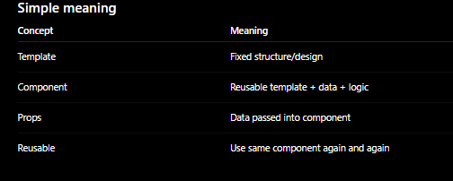

5 | What is state in React? | Internal data managed by a component.

6 | What is JSX? | JavaScript syntax extension that looks like HTML.

7 | Can a child component modify props? |  |  | No, props should be treated as read-only.
What are props? |  |  | Data passed from parent to child component.
 | Difference between usestate and useEffect?
 | 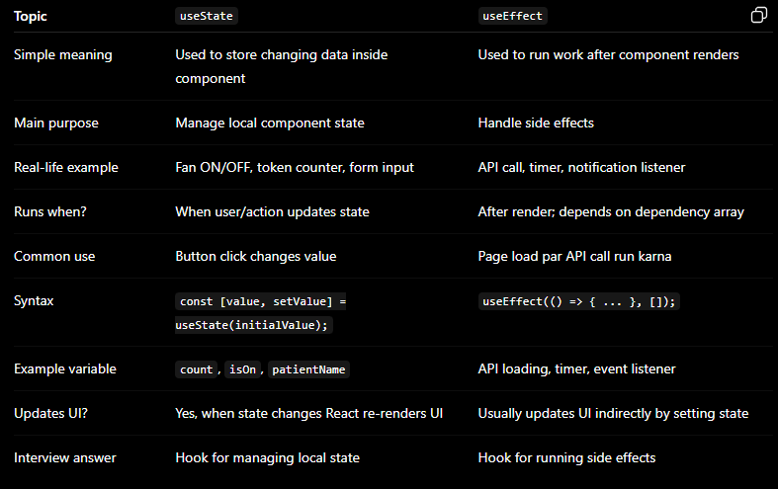
When does useEffect run?

After render; dependency array controls when it re-runs.

1. Cleanup in useEffect
Topic | Explanation
Simple meaning | Cleanup means removing/stopping something that was started in useEffect.
Why needed? | To avoid memory leaks, duplicate timers, duplicate listeners, or unwanted background work.
Real-life example | You enter a room and turn on a fan. When you leave the room, you should turn off the fan.
React example | If you start a timer, event listener, or subscription, stop it in cleanup.
Syntax | return () => { cleanup code }
Real-life example: Live clock timer
Imagine hospital dashboard has a live clock. When dashboard opens, timer starts. When dashboard closes, timer should stop.
import { useEffect, useState } from "react";
function LiveClock() {
const [time, setTime] = useState(new Date().toLocaleTimeString());
useEffect(() => {
const timerId = setInterval(() => {
setTime(new Date().toLocaleTimeString());
}, 1000);
// cleanup function
return () => {
clearInterval(timerId);
};
}, []);
return (
<div>
<h2>Current Time: {time}</h2>
</div>
);
}
export default LiveClock;
What is useRef?
Topic | Explanation
Simple meaning | useRef is used to store a value without causing re-render.
DOM use | It can directly reference an input, button, video, etc.
Value storage use | It can store mutable values like timer ID, previous value, click count, etc.
Re-render? | Changing ref.current does not re-render the component.
Syntax | const myRef = useRef(initialValue);
React docs say refs are useful when you need to store information that does not affect rendering. Changing a ref does not trigger a re-render.

4. useRef Example: Focus Input Automatically
Real-life example
When receptionist opens patient registration form, cursor should automatically go inside patient name input.
import { useEffect, useRef } from "react";
function PatientNameInput() {
const inputRef = useRef(null);
useEffect(() => {
inputRef.current.focus();
}, []);
return (
<div>
<h2>Patient Registration</h2>
<input
ref={inputRef}
type="text"
placeholder="Enter patient name"
/>
</div>
);
}
export default PatientNameInput;
Dependency array
Dependency array means the list of values that tells useEffect when to run again.
React official docs say: when you pass dependencies, the Effect runs after the first render and again whenever those dependency values change. Example: useEffect(() => {}, [a, b]) runs again if a or b changes.
Real-life example
Imagine you have an AC remote.
The AC should update only when:
- Temperature changes
- Mode changes
So temperature and mode are like dependencies.
In React:
useEffect(() => {
console.log("AC setting updated");
}, [temperature, mode]);
This means:
“Run this code when temperature or mode changes.”
What happens if dependency array is empty?

Effect runs once after initial render.
1. What are the Rules of Hooks?
Rules of Hooks mean: React Hooks ko use karne ke liye kuch important rules follow karne hotay hain.
React official docs ke mutabiq, Hooks ko top level par call karna chahiye, aur Hooks sirf React function components ya custom Hooks ke andar call honay chahiye. Hooks ko loops, conditions, nested functions, event handlers, class components, ya try/catch/finally blocks ke andar call nahi karna chahiye.
Real-life example
Imagine hospital mein patients line mein kharay hain:
Patient 1
Patient 2
Patient 3
Receptionist har dafa same order mein patients ko call karti hai.
Agar kabhi Patient 2 ko skip kar diya, kabhi Patient 3 ko pehle call kar diya, to system confuse ho jayega.
React Hooks bhi same order mein call honay chahiye har render par. Is liye Hooks ko condition ya loop ke andar nahi rakhte.

Rule 1: Call Hooks only at the top level
Correct way
import { useState, useEffect } from "react";
function PatientDashboard() {
const [patients, setPatients] = useState([]);
const [loading, setLoading] = useState(true);
useEffect(() => {
console.log("Dashboard loaded");
}, []);
return (
<div>
<h2>Patient Dashboard</h2>
</div>
);
}
export default PatientDashboard;
Here Hooks are at the top level of the component.

Wrong way
import { useState } from "react";
function PatientDashboard({ isAdmin }) {
if (isAdmin) {
const [patients, setPatients] = useState([]);
}
return (
<div>
<h2>Patient Dashboard</h2>
</div>
);
}
export default PatientDashboard;
This is wrong because useState is inside if.
React docs explain this rule helps ensure Hooks are called in the same order each time the component renders.
2. What is a Custom Hook?
A custom Hook is your own reusable function that uses React Hooks internally.
React docs say a custom Hook is like a normal function, but its name should start with use, so React and developers know that the Rules of Hooks apply to it.
Real-life example
Suppose your hospital app has many pages where you need to check internet status:
Dashboard page
Patient page
Appointment page
Billing page
Instead of writing online/offline logic on every page, you create one custom Hook:
useOnlineStatus
Then reuse it anywhere.

Custom Hook Example: Online / Offline Status
Step 1: Create custom Hook
import { useEffect, useState } from "react";
function useOnlineStatus() {
const [isOnline, setIsOnline] = useState(navigator.onLine);
useEffect(() => {
function handleOnline() {
setIsOnline(true);
}
function handleOffline() {
setIsOnline(false);
}
window.addEventListener("online", handleOnline);
window.addEventListener("offline", handleOffline);
return () => {
window.removeEventListener("online", handleOnline);
window.removeEventListener("offline", handleOffline);
};
}, []);
return isOnline;
}
export default useOnlineStatus;
Step 2: Use custom Hook in component
import useOnlineStatus from "./useOnlineStatus";
function Dashboard() {
const isOnline = useOnlineStatus();
return (
<div>
<h2>Hospital Dashboard</h2>
<p>Status: {isOnline ? "Online" : "Offline"}</p>
</div>
);
}
export default Dashboard;

Why custom Hook is useful?
Without custom Hook | With custom Hook
Same logic repeated in many components | Logic written once
Code becomes messy | Code becomes clean
Hard to update | Easy to update
More duplicate code | Reusable logic
What is Prop Drilling?
Prop drilling means passing data from parent component to deeply nested child component through many middle components.
Example: E-commerce website
Imagine an online shopping website:
App
↓
Layout
↓
Navbar
↓
UserMenu
↓
ProfileButton
Now suppose only ProfileButton needs the user name:
User name = "Ali"
But the data travels like this:
App → Layout → Navbar → UserMenu → ProfileButton
Here, Layout, Navbar, and UserMenu do not need the user name. They are only forwarding it.
That is prop drilling.
Code example
function App() {
const userName = "Ali";
return <Layout userName={userName} />;
}
function Layout({ userName }) {
return <Navbar userName={userName} />;
}
function Navbar({ userName }) {
return <UserMenu userName={userName} />;
}
function UserMenu({ userName }) {
return <ProfileButton userName={userName} />;
}
function ProfileButton({ userName }) {
return <button>{userName}</button>;
}
What is the problem here?
Only this component needs userName:
function ProfileButton({ userName }) {
return <button>{userName}</button>;
}
But these components are also receiving it:
Layout
Navbar
UserMenu
They do not use it. They only pass it forward.
Simple definition
Prop drilling means:
Passing props through many middle components, even when those middle components do not need the data.
Another real-life example: Office message
CEO
↓
Manager
↓
Team Lead
↓
Developer
↓
Intern
Only the Intern needs the message:
"Submit your report today"
But CEO gives it to Manager, Manager gives it to Team Lead, Team Lead gives it to Developer, Developer gives it to Intern.
22. How can you avoid Prop Drilling?
You can avoid prop drilling mainly by:
Method | Meaning | Best For
Context API | Share data globally within component tree | Theme, logged-in user, language, hospital info
State management library | External global state tool | Large apps with complex state
Component composition | Pass UI/components instead of passing many props | Cleaner layouts and reusable screens
React’s older docs also define Context as a way to pass data through the component tree without manually passing props at every level, especially for data like current user, theme, or language.

Solution 1: Avoid Prop Drilling Using Context API
Real-life example
Instead of giving hospital name to every person manually, hospital announces it on a central system.
Now any department can read it directly.
Hospital Context = central announcement system
Code Example Using Context API
import { createContext, useContext } from "react";
const HospitalContext = createContext();
function App() {
const hospitalName = "Medcare Hospital";
return (
<HospitalContext.Provider value={hospitalName}>
<Dashboard />
</HospitalContext.Provider>
);
}
function Dashboard() {
return <PatientSection />;
}
function PatientSection() {
return <PatientCard />;
}
function PatientCard() {
const hospitalName = useContext(HospitalContext);
return (
<div>
<h2>Patient Card</h2>
<p>Hospital: {hospitalName}</p>
</div>
);
}
export default App;
State is memory for a React component, not memory like RAM/database.
What is Controlled Component?
Controlled component means: form input ka value React state control karti hai.
React docs explain that an input is controlled when you pass a value prop to it, and you update that value through state, usually with onChange. The controlled value should not be undefined or null; for an empty text field, initialize state as "".
Real-life example
Imagine a receptionist form.
Receptionist types patient name:
Ali Khan
React immediately stores that value in state:
patientName = "Ali Khan"
So React knows the current input value all the time.
Controlled Component Code
import { useState } from "react";
function ControlledPatientForm() {
const [patientName, setPatientName] = useState("");
function handleSubmit(event) {
event.preventDefault();
alert(`Patient Name: ${patientName}`);
}
return (
<form onSubmit={handleSubmit}>
<h2>Controlled Component</h2>
<input
type="text"
placeholder="Enter patient name"
value={patientName}
onChange={(event) => setPatientName(event.target.value)}
/>
<p>Typing: {patientName}</p>
<button type="submit">Submit</button>
</form>
);
}
export default ControlledPatientForm;
Explanation
Code | Meaning
useState("") | Patient name state banayi
value={patientName} | Input ka value React state se aa raha hai
onChange={...} | Har typing par state update hoti hai
patientName | React ke paas latest value hoti hai
What is Uncontrolled Component?
Uncontrolled component means: form input ka value DOM/browser khud manage karta hai, React state nahi.
React docs say uncontrolled components keep the source of truth in the DOM. Instead of writing an event handler for every update, you can use a ref to read the value when needed.
Real-life example
Imagine receptionist writes patient name on a paper form.
React does not track every letter while typing.
When submit button is clicked, React reads the final value from the input.
Uncontrolled Component Code
import { useRef } from "react";
function UncontrolledPatientForm() {
const patientNameRef = useRef(null);
function handleSubmit(event) {
event.preventDefault();
alert(`Patient Name: ${patientNameRef.current.value}`);
}
return (
<form onSubmit={handleSubmit}>
<h2>Uncontrolled Component</h2>
<input
type="text"
placeholder="Enter patient name"
ref={patientNameRef}
/>
<button type="submit">Submit</button>
</form>
);
}
export default UncontrolledPatientForm;
Explanation
Code | Meaning
useRef(null) | Input ka reference banaya
ref={patientNameRef} | Ref ko input se connect kiya
patientNameRef.current.value | DOM se current value read ki
No value state | React input ko control nahi kar raha
Controlled vs Uncontrolled Component Table
Feature |  | Controlled Component |  | Uncontrolled Component
Value controlled by |  | React state |  | DOM/browser
Uses useState? |  | Yes |  | Usually no
Uses ref? |  | Usually no |  | Yes
Tracks every keystroke? |  | Yes |  | No
Best for |  | Validation, search, dynamic forms, conditional UI |  | Simple forms, quick value reading
Input value prop |  | value={state} |  | defaultValue or no value
Submit value from |  | State variable |  | ref.current.value
React control level |  | High |  | Low
Topic | Roman Urdu

Controlled component | Input ka control React state ke paas hota hai

Uncontrolled component | Input ka control browser/DOM ke paas hota hai

Controlled example | Har typed letter React state mein save hota hai

Uncontrolled example | Submit par input se value read karte hain
Interview Answer
A controlled component is a form input whose value is controlled by React state using value and onChange. React always knows the latest input value.
An uncontrolled component is a form input whose value is managed by the DOM itself. React reads the value only when needed, usually using useRef.
Yes, your understanding is mostly correct.
When a form input value like email/password is stored in React state and the input uses that state through value + onChange, then it is a controlled component.
Lifting state up
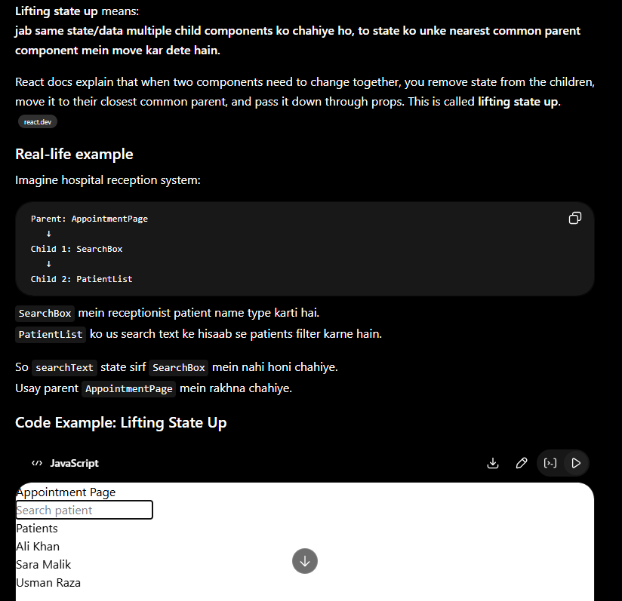
What is React Fragment?
React Fragment is a wrapper that lets you return multiple elements without adding an extra HTML node to the DOM.
React docs say fragments let you group children without adding extra nodes to the DOM.
Problem without Fragment
React component normally returns one parent wrapper.
function PatientCard() {
return (
<div>
<h2>Ali Khan</h2>
<p>Age: 35</p>
</div>
);
}
This works, but it adds an extra <div> in HTML.
Output:
<div>
<h2>Ali Khan</h2>
<p>Age: 35</p>
</div>
Sometimes you do not want extra <div>.

Solution: React Fragment
function PatientCard() {
return (
<>
<h2>Ali Khan</h2>
<p>Age: 35</p>
</>
);
}
export default PatientCard;
Here:
<>
...
</>
is a React Fragment.
React fragment prevents code from becoming messy .
What is React Router?
React Router is a library used for navigation/routing in React apps.
Simple meaning:
React Router helps you move from one page to another page in a React app without reloading the whole website.
React Router docs say users can navigate an app with components like <Link>, <NavLink>, and useNavigate.
Real-life example
Imagine a hospital web app:
/dashboard
/patients
/appointments
/billing
When user clicks Patients, only the Patients screen changes.
The full website does not reload.
React Router example
First install:
npm install react-router-dom
Then create routes:
import { BrowserRouter, Routes, Route, Link } from "react-router-dom";
function App() {
return (
<BrowserRouter>
<nav>
<Link to="/">Dashboard</Link>
<Link to="/patients">Patients</Link>
<Link to="/appointments">Appointments</Link>
</nav>
<Routes>
<Route path="/" element={<Dashboard />} />
<Route path="/patients" element={<Patients />} />
<Route path="/appointments" element={<Appointments />} />
</Routes>
</BrowserRouter>
);
}
function Dashboard() {
return <h2>Dashboard Page</h2>;
}
function Patients() {
return <h2>Patients Page</h2>;
}
function Appointments() {
return <h2>Appointments Page</h2>;
}
export default App;
28. Difference Between Link and <a> Tag
Both are used for navigation, but in React apps they behave differently.
Feature | <Link> | <a> tag
From | React Router | HTML/browser
Used for | Internal React app navigation | External links or normal HTML navigation
Page reload | No full page reload | Usually causes browser navigation/page reload
Attribute | to="/patients" | href="/patients"
Best for | React internal pages | External websites, downloads, email links
Example | <Link to="/patients">Patients</Link>
What is Lazy Loading in React?
Lazy loading means:
component ko tab load karna jab uski zaroorat ho.
Normally, React app may load many components at start. But with lazy loading, we load only the important page first. Other pages/components load later when user opens them.
React docs explain that lazy lets you defer loading a component’s code until it is rendered for the first time. It is commonly used with Suspense to show fallback UI while the component is loading.
Real-life example
Imagine hospital dashboard has these pages:
Dashboard
Patients
Appointments
Billing
Reports
When user opens app, maybe only Dashboard is needed first.
So instead of loading all pages at start:
Load Dashboard + Patients + Appointments + Billing + Reports
Lazy loading does this:
First load Dashboard only
Load Patients only when user clicks Patients
Load Reports only when user clicks Reports
Lazy Loading Code Example
import { lazy, Suspense } from "react";
import { BrowserRouter, Routes, Route, Link } from "react-router-dom";
const Dashboard = lazy(() => import("./pages/Dashboard"));
const Patients = lazy(() => import("./pages/Patients"));
const Appointments = lazy(() => import("./pages/Appointments"));
function App() {
return (
<BrowserRouter>
<nav>
<Link to="/">Dashboard</Link>
<Link to="/patients">Patients</Link>
<Link to="/appointments">Appointments</Link>
</nav>
<Suspense fallback={<h2>Loading page...</h2>}>
<Routes>
<Route path="/" element={<Dashboard />} />
<Route path="/patients" element={<Patients />} />
<Route path="/appointments" element={<Appointments />} />
</Routes>
</Suspense>
</BrowserRouter>
);
}
export default App;
Explanation
Code | Meaning
lazy(() => import("./pages/Patients")) | Patients component lazy load hoga
Suspense | Loading time par fallback UI show karega
fallback={<h2>Loading page...</h2>} | Jab component load ho raha ho, ye text show hoga
User clicks Patients | Tab Patients component download/load hoga
What is Code Splitting?
Code splitting means:
JavaScript bundle ko chotay chunks/files mein divide karna.
Instead of sending one big JavaScript file to browser, app sends smaller files when needed.
React’s old docs explain that bundling is useful, but as an app grows, the bundle can get large. Code splitting helps create multiple bundles and load them dynamically at runtime.
Real-life example
Imagine a hospital has one big file with all departments:
Reception + Billing + Reports + Admin + HR + Pharmacy
Even if receptionist only needs Reception page, system loads everything.
Code splitting says:
Reception file separate
Billing file separate
Reports file separate
Admin file separate
Now browser loads only what is needed.
Code Splitting Example
This line causes code splitting:
const Reports = lazy(() => import("./pages/Reports"));
Because Reports is imported dynamically only when needed.
Full example:
import { lazy, Suspense } from "react";
const Reports = lazy(() => import("./pages/Reports"));
function ReportsPageWrapper() {
return (
<Suspense fallback={<p>Loading reports...</p>}>
<Reports />
</Suspense>
);
}
export default ReportsPageWrapper;
React component lifecycle means:
A component has a “life” from appearing on screen, changing, and then disappearing from screen.
React lifecycle has 3 main stages:
Lifecycle stage | Easy meaning | Real-life example
Mounting | Component appears first time | Patient enters hospital
Updating | Component changes because state/props changed | Patient status changes from “waiting” to “checked”
Unmounting | Component is removed from screen | Patient leaves hospital
In class components, React had lifecycle methods like componentDidMount, componentDidUpdate, and componentWillUnmount. In functional components, we mostly use useEffect for this. React docs say useEffect can behave like these lifecycle methods depending on dependency array and cleanup function. (React)
1. Mounting
Mounting means component appears on screen for the first time.
Example: Dashboard opens and patient list loads.
import { useEffect } from "react";

function PatientList() {
useEffect(() => {
console.log("Component mounted: Patient list opened");
}, []);

return <h2>Patient List</h2>;
}

export default PatientList;
Here:
useEffect(() => {
console.log("Component mounted");
}, []);
[] means run only one time when component first appears.
Real-life:
Patient enters hospital reception first time.
Receptionist creates entry.
In React:
Component appears first time.
React runs mounting logic.
2. Updating
Updating means component re-renders because state or props changed.
Example: User clicks button and count changes.
import { useState, useEffect } from "react";

function CallCounter() {
const [calls, setCalls] = useState(0);

useEffect(() => {
console.log("Component updated: calls changed", calls);
}, [calls]);

return (
<div>
<h2>Total Calls: {calls}</h2>
<button onClick={() => setCalls(calls + 1)}>
Add Call
</button>
</div>
);
}

export default CallCounter;
Here:
useEffect(() => {
console.log("calls changed");
}, [calls]);
This runs when calls changes.
Real-life:
Reception dashboard shows total calls = 0.
New call comes.
Dashboard updates total calls = 1.
Another call comes.
Dashboard updates total calls = 2.
That is updating lifecycle.
3. Unmounting
Unmounting means component is removed from screen.
Example: User closes a chat box or leaves a page.
import { useEffect } from "react";

function LiveCallBox() {
useEffect(() => {
console.log("Live call box opened");

return () => {
console.log("Live call box closed");
};
}, []);

return <h2>Live Call Running...</h2>;
}

export default LiveCallBox;
Here this part runs when component appears:
console.log("Live call box opened");
This cleanup part runs when component is removed:
return () => {
console.log("Live call box closed");
};
React docs explain that cleanup runs when component unmounts, and also before effect runs again when dependencies change. (React)
Real-life:
Patient leaves hospital.
Receptionist closes patient file.
In React:
Component removed from screen.
React runs cleanup.
Full example: Mount, Update, Unmount
import { useState, useEffect } from "react";

function AppointmentStatus() {
const [status, setStatus] = useState("Waiting");

// Mounting
useEffect(() => {
console.log("Appointment component mounted");

// Unmounting
return () => {
console.log("Appointment component unmounted");
};
}, []);

// Updating
useEffect(() => {
console.log("Status updated:", status);
}, [status]);

return (
<div>
<h2>Appointment Status: {status}</h2>

<button onClick={() => setStatus("Checked In")}>
Check In
</button>

<button onClick={() => setStatus("Completed")}>
Complete
</button>
</div>
);
}

export default AppointmentStatus;
Very easy hospital example
Imagine your React component is a patient appointment card.
1. Mounting
Patient appointment card appears on dashboard.

2. Updating
Appointment status changes:
Waiting → Checked In → Completed

3. Unmounting
Appointment card is removed from dashboard.
Simple interview answer
You can say:
React component lifecycle means the stages of a component: mounting, updating, and unmounting. Mounting means component appears first time, updating means component changes because state or props changed, and unmounting means component is removed from the screen. In functional components, we handle lifecycle behavior using useEffect.
Quick memory trick
Mounting = Born
Updating = Growing / changing
Unmounting = Removed / dead
So React component life cycle is simply:
Component comes → Component changes → Component goes
Redux official docs define Redux as a JavaScript library for predictable and maintainable global state management.
Why do we need Redux?
Redux is like one central storage room for your app data.
Redux Toolkit is the easier and modern way to write Redux code.

In React, each component has its own state:
const [user, setUser] = useState(null);
This is okay for small data. But in a big app, many components may need the same data.
Example:
Navbar needs user name
Dashboard needs user role
Sidebar needs permissions
Profile page needs user details
Instead of passing data again and again through props, Redux keeps data in one central place called store.
Real-life example
Imagine a hospital system.
Without Redux:
Reception has patient data
Doctor needs patient data
Billing needs patient data
Lab needs patient data
Pharmacy needs patient data
You pass data from one department to another manually. This becomes confusing.
With Redux:
Central Hospital Database
↓
Reception
Doctor
Billing
Lab
Pharmacy
Everyone reads from the same central place.
In React:
Redux Store
↓
Navbar
Dashboard
Sidebar
Profile
Main Redux terms
Term | Easy meaning | Example
Store | Central place where app data is stored | Logged-in user, theme, cart items
State | Actual data inside store | { count: 0 }
Action | Message saying what happened | "increment"
Reducer | Function that updates state based on action | Add 1 to count
Dispatch | Sending an action | dispatch(increment())
Selector | Reading data from store | useSelector()
React Redux provides hooks like useSelector to read store data and useDispatch to send actions.
Boilerplate code means code that you have to write again and again with little change.
Real-life example
Imagine you send many emails:
Dear Sir/Madam,
I hope you are doing well.
Best regards,
Your Name
This same structure is repeated in many emails. Only the main message changes.
That repeated structure is like boilerplate
Redux toolkit
Redux Toolkit
Old Redux had more boilerplate code. You had to write action types, action creators, reducers, and store setup separately.
Redux Toolkit makes Redux easier by giving tools like:
Redux Toolkit feature | Meaning
configureStore() | Creates Redux store easily
createSlice() | Creates reducer + actions together
Provider | Makes store available to React app
useSelector() | Reads data from store
useDispatch() | Updates data in store
Redux Toolkit is the recommended modern way to write Redux. Its API is designed to simplify Redux setup and usage.
Simple Redux Toolkit example
1. Install packages
npm install @reduxjs/toolkit react-redux
2. Create slice
File:
src/features/counter/counterSlice.js
import { createSlice } from "@reduxjs/toolkit";
const counterSlice = createSlice({
name: "counter",
initialState: {
value: 0,
},
reducers: {
increment: (state) => {
state.value += 1;
},
decrement: (state) => {
state.value -= 1;
},
reset: (state) => {
state.value = 0;
},
},
});
export const { increment, decrement, reset } = counterSlice.actions;
export default counterSlice.reducer;
3. Create store
File:
src/app/store.js
import { configureStore } from "@reduxjs/toolkit";
import counterReducer from "../features/counter/counterSlice";
export const store = configureStore({
reducer: {
counter: counterReducer,
},
});
4. Wrap app with Provider
File:
src/main.jsx
import React from "react";
import ReactDOM from "react-dom/client";
import { Provider } from "react-redux";
import App from "./App";
import { store } from "./app/store";
ReactDOM.createRoot(document.getElementById("root")).render(
<Provider store={store}>
<App />
</Provider>
);
5. Use Redux state in component
File:
src/App.jsx
import { useSelector, useDispatch } from "react-redux";
import { increment, decrement, reset } from "./features/counter/counterSlice";
function App() {
const count = useSelector((state) => state.counter.value);
const dispatch = useDispatch();
return (
<div>
<h1>Count: {count}</h1>
<button onClick={() => dispatch(increment())}>
Increase
</button>
<button onClick={() => dispatch(decrement())}>
Decrease
</button>
<button onClick={() => dispatch(reset())}>
Reset
</button>
</div>
);
}
export default App;
How Redux flow works
User clicks button
↓
dispatch(increment())
↓
Action goes to reducer
↓
Reducer updates store
↓
Component gets new value
↓
UI updates
Redux vs Redux Toolkit
Point | Redux old way | Redux Toolkit
Code length | More code | Less code
Store setup | Manual | Easy with configureStore()
Actions | Write separately | Auto-created by createSlice()
Reducers | More boilerplate | Simple syntax
Recommended now | Not preferred for new apps | Yes, preferred
When should you use Redux?
Use Redux when:
Many components need same data
Login/user data is needed everywhere
Cart data is needed everywhere
Theme/permissions are global
App is large
State updates are complex
Do not use Redux for every small thing. For simple local state, use useState.
Example:
const [isOpen, setIsOpen] = useState(false);
This kind of small UI state does not always need Redux.
Easy interview answer
Redux is a global state management library. It stores app data in one central store so multiple components can access the same data without prop drilling. Redux Toolkit is the modern recommended way to write Redux because it reduces boilerplate and gives easy functions like configureStore and createSlice.
Simple memory:
Redux = central storage
Redux Toolkit = easy way to use Redux
First understand DOM
DOM stands for Document Object Model.
When browser loads HTML, it makes a tree-like structure.
Example HTML:
<div>
<h1>Hello</h1>
<p>Welcome</p>
</div>
Browser converts it into DOM tree:
div
├── h1 = Hello
└── p = Welcome
This is called Real DOM.
Problem with Real DOM
Changing Real DOM again and again can be slow.
Example:
If your React app has 1000 elements and only one button text changes, updating the whole DOM would be inefficient.
Virtual DOM solution
React keeps a lightweight copy of UI in memory.
When state changes, React does this:
1. State changes
2. React creates new Virtual DOM
3. React compares old Virtual DOM with new Virtual DOM
4. React finds only changed part
5. React updates only that part in Real DOM
React’s current docs describe this as: when a render is triggered, React calls your components to figure out what should appear on screen; then React commits the needed changes to the DOM.
Simple real-life example
Imagine a hospital patient board:
Patient Name: Ali
Status: Waiting
Doctor: Dr. Ahmed
Now only status changes:
Status: In Progress
Without Virtual DOM, system may repaint/check the whole board.
With Virtual DOM, React says:
Only "Status" changed.
Update only Status.
Do not touch Patient Name and Doctor.
31. What is React.memo?
React.memo is used to stop a child component from re-rendering again and again when its props have not changed. React’s docs say memo lets you skip re-rendering a component when its props are unchanged, but it is a performance optimization, not a guarantee.
Easy example
Imagine a hospital dashboard:
Parent Component: Dashboard
├── PatientList
├── DoctorCard
└── Counter
Now only Counter changes.
Without React.memo, DoctorCard may also re-render when parent re-renders.
With React.memo, React says:
DoctorCard props same hain.
Isko dobara render karne ki zaroorat nahi.
Code example
import React, { memo, useState } from "react";
const DoctorCard = memo(function DoctorCard({ name }) {
console.log("DoctorCard rendered");
return <h2>Doctor: {name}</h2>;
});
function Dashboard() {
const [count, setCount] = useState(0);
return (
<div>
<DoctorCard name="Dr. Ahmed" />
<p>Counter: {count}</p>
<button onClick={() => setCount(count + 1)}>
Increase Counter
</button>
</div>
);
}
export default Dashboard;
When you click the button, count changes. But DoctorCard still receives same prop:
name="Dr. Ahmed"
So DoctorCard does not need to re-render.
What is useMemo?
useMemo is used to cache a calculated value between renders. React’s docs define useMemo as a Hook that caches the result of a calculation between re-renders. If dependencies do not change, React returns the previously stored value instead of running the calculation again.
Easy example
Suppose you have 10,000 patients and you are filtering only “active patients”.
Filtering again and again can be expensive.
Without useMemo:
Every render → filter all patients again
With useMemo:
patients same hain → old filtered result use karo
patients change hue → filter dobara run karo
Code example
Here, typing in the search box changes search, but patients did not change. So this calculation will not run again:
patients.filter((patient) => patient.status === "active")

Main difference
Feature | React.memo | useMemo
Used for | Component | Value/calculation
Purpose | Stop unnecessary child component re-render | Stop expensive calculation from running again
Example | Do not re-render DoctorCard if props same | Do not filter 10,000 patients again if patients same
Type | Higher-order component | React Hook
For useMemo:
Same dependency → use old calculated value
Changed dependency → calculate new value
For useCallback:
Same dependency → use old function
Changed dependency → create new function
So easy line:
Cache ka matlab hai:
React kisi value ya function ko yaad rakh leta hai,
taake same cheez dobara calculate/create na karni paray.
Optimize React performance
Technique | Meaning | Example
Memoization | Cache value/function/component | Do not filter patients again if patients did not change
Lazy loading | Load component only when needed | Load Reports page only when user opens it
Pagination | Show data page by page | Show 50 claims per page
Virtualization | Render only visible rows | Show only visible patients from 10,000 list
Avoid unnecessary state | Do not store derived data in state | Calculate fullName instead of storing it
. What is reconciliation?
Reconciliation means React compares the previous UI tree with the new UI tree and decides what needs to change in the real DOM.
React says it can efficiently update and render the right components when data changes. In old React docs, this comparison/sync process is called reconciliation.
Easy example
Old UI:
<p>Status: Waiting</p>
New UI:
<p>Status: Confirmed</p>
React compares both and says:
Only text changed from Waiting to Confirmed.
Update only this paragraph in real DOM.
Medical dashboard scenario
Patient appointment card:
Patient: Ali
Doctor: Dr. Ahmed
Status: Waiting
Now status changes:
Status: Checked In
React does not rebuild the full page. It compares old UI and new UI, then updates only the changed status.
Interview answer:
Reconciliation is React’s process of comparing the old UI tree with the new UI tree and updating only the necessary parts of the real DOM.

39. What is hydration?
Hydration means React takes HTML that was already created by the server and attaches React behavior to it in the browser.
React official docs say hydration attaches your components’ logic to the initial HTML generated by the server and turns that HTML snapshot into a fully interactive app.
Easy example
Server sends this HTML:
<button>Book Appointment</button>
At first, browser can show the button, but React behavior is not attached yet.
After hydration, React attaches JavaScript behavior:
<button onClick={bookAppointment}>Book Appointment</button>
Now button becomes clickable and interactive.
Medical receptionist scenario
Server sends appointment page quickly:
Patient Name: Ali
Button: Book Appointment
User can see the page fast. Then React loads in browser and attaches actions:
Click Book Appointment → opens booking modal
Click Cancel → cancels appointment
Click Search → filters patients
That process is hydration.
Interview answer:
Hydration is the process where React attaches event handlers and interactive behavior to server-rendered HTML.

40. What is error boundary?
An error boundary is a React component that catches errors in its child component tree and shows a fallback UI instead of crashing the whole app.
React docs define error boundaries as components that catch JavaScript errors anywhere in their child component tree, log them, and display fallback UI instead of the crashed tree.
Easy example
Suppose this component crashes:
function PatientCard() {
throw new Error("Patient data missing");
return <p>Patient Card</p>;
}
Without error boundary:
Whole app may crash.
With error boundary:
Only PatientCard area shows:
"Something went wrong."
Rest of dashboard keeps working.
Medical dashboard scenario
Your dashboard has:
Appointment List
Patient Card
Billing Summary
AI Call Transcript
If AI Call Transcript crashes because transcript data is missing, the full dashboard should not crash.
Instead, error boundary shows:
Unable to load transcript. Please try again.
Other parts still work.
Class component example
import React from "react";
class ErrorBoundary extends React.Component {
constructor(props) {
super(props);
this.state = {
hasError: false,
};
}
static getDerivedStateFromError(error) {
return {
hasError: true,
};
}
componentDidCatch(error, errorInfo) {
console.log("Error caught:", error);
console.log("Error info:", errorInfo);
}
render() {
if (this.state.hasError) {
return <h2>Something went wrong. Please try again.</h2>;
}
return this.props.children;
}
}
export default ErrorBoundary;
Use it like this:
<ErrorBoundary>
<PatientCard />
</ErrorBoundary>
Now if PatientCard crashes, ErrorBoundary catches it and shows fallback UI.
Interview answer:
Error boundary is a React component that catches rendering errors in child components and shows fallback UI instead of crashing the whole app.

Simple comparison table
Concept | Meaning | Example
Reconciliation | Compare old UI and new UI | Status changed from Waiting to Checked In
Hydration | Attach React behavior to server HTML | Server sends button, React makes it clickable
Error boundary | Catch child component errors | Transcript component crashes, dashboard still works
Simple line:
Reconciliation = React compares UI changes
Hydration = React makes server HTML interactive
Error boundary = React catches UI errors safely
fetch API = frontend se backend/API ko request bhejna aur data receive karna it is get request or not ?
Thought for 10s
Yes — by default, fetch() sends a GET request.
What are promises?
A Promise is a JavaScript object that represents the future result of an asynchronous operation. MDN defines a Promise as representing the eventual completion or failure of an async operation and its resulting value.
Easy meaning
Promise means:
Kaam abhi complete nahi hua,
lekin future mein ya to success hoga ya fail hoga.
Example scenario:
Frontend sends request to backend:
"Give me patient appointments."
Backend takes time.
Promise says:
"I promise I will return result later:
either appointments data or error."
Promise has 3 states
State | Meaning | Example
Pending | Work is still running | API request is waiting
Fulfilled / Resolved | Work completed successfully | Data received
Rejected | Work failed | Server error / network error
Promise example
const appointmentPromise = fetch("https://api.example.com/appointments");
appointmentPromise
.then((response) => response.json())
.then((data) => {
console.log("Appointments:", data);
})
.catch((error) => {
console.log("Error:", error);
});
Here:
.then() = success case handle karta hai
.catch() = error case handle karta hai

57. What is async/await?
async/await is a cleaner way to write promise-based code. MDN says await waits for a Promise and gets its fulfilled value; it can be used inside an async function or at the top level of a module.
Same example with async/await
async function getAppointments() {
try {
const response = await fetch("https://api.example.com/appointments");
const data = await response.json();
console.log("Appointments:", data);
} catch (error) {
console.log("Error:", error);
}
}
getAppointments();
This code is easier to read because it looks like normal step-by-step code.
1. Wait for API response
2. Convert response to JSON
3. Show data
4. If error, catch it
MDN explains that async functions can contain await, and await makes promise-returning code behave more like synchronous code by pausing that async function until the Promise is fulfilled or rejected.

Real-life example
Imagine you order food online.
Promise
Restaurant says:
"Your food is being prepared. I promise I will tell you when it is ready or if it fails."
Possible results:
Pending: Food is cooking
Fulfilled: Food delivered
Rejected: Order cancelled
async/await
You say:
Wait until food is delivered.
Then eat it.
If order fails, show error.
async is used when a task takes time, and we do not want to block the whole app while waiting.

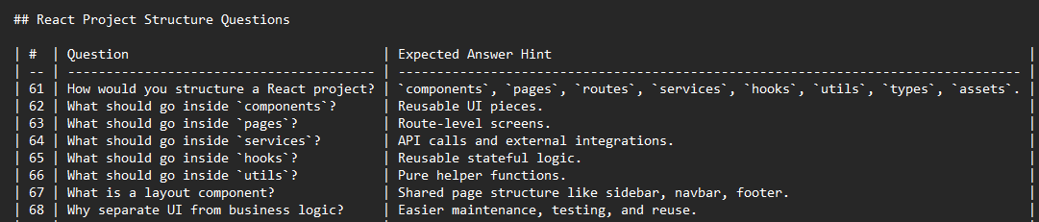
Rendering
In React, rendering means React calls your component function to understand what should appear on the screen. React docs explain: “Rendering” is React calling your components to figure out what to display.
Simple example
function PatientCard() {
return <h2>Patient Name: Ali</h2>;
}
When React runs this component and shows this on screen:
Patient Name: Ali
That is called rendering
Re-render
means: React runs the component again to update the UI when data changes.
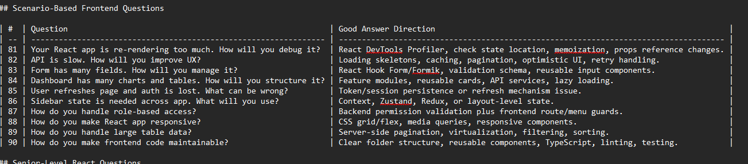

Sure. Here is a proper table for Chrome DevTools with easy explanation and examples.
Chrome DevTools is a set of developer tools built directly into Chrome. It helps you inspect pages, debug code, check API requests, and fix performance issues. (Chrome for Developers)
DevTools Tab | What it means | What you can check | Example scenario
Elements | Shows the page HTML and CSS | HTML structure, CSS styles, layout, spacing, colors | Your Book Appointment button is not visible. You inspect it and find display: none in CSS.
Console | Shows JavaScript logs and errors | console.log, JS errors, warnings | Your React page is blank. Console shows: Cannot read properties of undefined. This means some data is missing or used incorrectly.
Network | Shows all API and file requests | API URL, method, status code, payload, response | Your patient list is not loading. In Network tab you see GET /api/patients returned 500, meaning backend error.
Sources | Used for JavaScript debugging | Code files, breakpoints, step-by-step debugging | You put a breakpoint inside handleSubmit() to check why appointment booking function is not working. Chrome DevTools supports debugging JavaScript directly in the browser. (Chrome for Developers)
Application | Shows browser storage data | Local storage, session storage, cookies, cache | Login is not working. You check localStorage and see the auth token is missing.
Performance | Checks website speed and rendering issues | Slow rendering, long tasks, UI lag | Your dashboard becomes slow when showing 10,000 patients. Performance tab helps identify what is taking time.
Lighthouse | Gives website audit report | Performance, accessibility, SEO, best practices | You run Lighthouse and it tells you the website is slow because images are too large.
React DevTools | Extra extension for React apps | Components, props, state, re-renders | You check why PatientCard re-renders again and again when props are not changing.
Example: Medical receptionist dashboard debugging
Suppose your React dashboard should show appointments, but the page is empty.
Step | DevTools tab | What you do | What you may find
1 | Console | Check JavaScript errors | appointments.map is not a function
2 | Network | Check API request | GET /api/appointments returned 404
3 | Network → Response | Check backend response | { "error": "Route not found" }
4 | Elements | Check if UI exists but hidden | Table exists but CSS color is white on white background
5 | Application | Check login token | Token expired or missing
6 | Sources | Add breakpoint in fetch function | Check if API URL is correct
Common status codes in Network tab
Status code | Meaning | Example
200 | Success | Patients data loaded successfully
201 | Created | Appointment booked successfully
400 | Bad request | Frontend sent wrong data
401 | Unauthorized | User is not logged in or token expired
403 | Forbidden | User does not have permission
404 | Not found | API route is wrong
500 | Server error | Backend crashed
Simple interview answer
Chrome DevTools is a built-in developer toolbox in Chrome used to inspect HTML/CSS, debug JavaScript, check API requests, view browser storage, and analyze website performance.
For interview preparation, focus first on these:
1. Components, props, state
2. `useState`, `useEffect`, `useRef`, `useContext`
3. Controlled vs uncontrolled components
4. API calls and loading/error handling
5. React Router and protected routes
6. Folder structure
7. Performance optimization
8. Form handling
9. State management
10. Real project architecture
The Context API
is a built-in React feature that allows you to share data globally across a component tree without having to manually pass "props" through every intermediate level

